Solution Brief
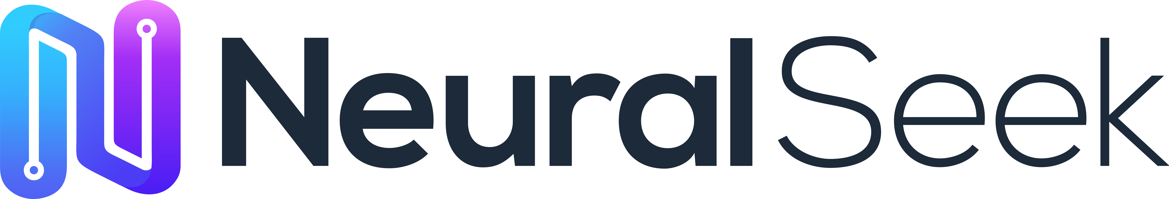

NeuralSeek + IBM Fusion

Secure, No-Code AI for Regulated Enterprises

Executive Summary
Enterprises in regulated industries face a fundamental barrier to AI adoption: public-cloud LLMs and SaaS AI agents cannot guarantee data sovereignty, strict access control, or compliance with frameworks such as HIPAA, PCI-DSS, FINRA, GDPR, or CJIS. Sending prompts or documents to external endpoints risks exposure of sensitive information, while multi-tenant architectures introduce unacceptable uncertainty around data retention, cross-customer bleed, and auditability.
NeuralSeek + IBM Fusion solves this problem by delivering a fully governed, behind-the-firewall AI platform that transforms private enterprise data into production-ready applications—without exposing any information to external networks. NeuralSeek provides deterministic, source-grounded responses, while IBM Fusion enforces policy-driven orchestration, identity, and governance. Together, they unlock AI productivity gains while preserving complete control over data, workflows, and compliance.

The Problem: AI Adoption in Regulated Industries
Boards in banking, insurance, healthcare, government, energy and other regulated sectors are under pressure to deliver AI productivity — yet the only readily available options are public, multi‑tenant SaaS LLMs and AI agents that were never designed for the controls these industries are legally required to enforce. Sending prompts, documents, customer records or trade data to an external endpoint is, in many cases, a regulatory violation in waiting. The result is a widening gap: business units are racing ahead with shadow AI while risk, security, audit and compliance teams are forced to slow or block deployments because the platforms cannot prove what they did, with what data, on whose behalf.
Specifically, regulated organizations are struggling with:
- Data sovereignty and residency risk — public‑cloud LLMs route prompts, embeddings and uploaded documents through provider infrastructure where data location, sub‑processors and training‑reuse policies are outside the customer’s control.
- No zero‑trust enforcement at the model edge — identity, RBAC, group policies and DLP that work for files and databases are bypassed the moment a user pastes content into an external chatbot or agent.
- Hallucinations and non‑deterministic outputs — LLMs invent citations, names, dosages, dollar amounts and legal clauses; in regulated workflows a single fabricated fact can trigger fines, lawsuits or patient harm.
- No audit trail or replay — most SaaS AI services cannot reconstruct, on demand, the exact prompt, sources, model, parameters and response delivered to a specific user at a specific time — the baseline an examiner, regulator or internal auditor will ask for.
- PII, PHI and trade‑secret leakage — without inline detection and redaction, sensitive content silently flows into prompts, logs and analytics caches, creating GDPR, HIPAA, PCI and IP‑exposure incidents.
- Prompt injection and model abuse — external chat interfaces are increasingly weaponized to exfiltrate data, override system instructions, or coax models into unauthorized actions.
- Vendor lock‑in and retention ambiguity — single‑model SaaS bundles leave organizations unable to swap LLMs for cost or performance, and unable to guarantee that content has actually been purged from provider systems.
- Layered compliance exposure — HIPAA, PCI‑DSS, FINRA, SOX, GDPR, CJIS, ITAR, NYDFS, DORA and the EU AI Act each demand evidence that AI behavior is bounded, logged and reviewable — something public AI tooling is not architected to deliver.
- Hardware and infrastructure gap — even when policy allows on‑prem AI, most enterprises lack the GPU‑optimized, OpenShift‑ready hardware and operational tooling to actually run production LLM workloads behind their firewall.
The takeaway is straightforward: regulated industries do not need another general‑purpose chatbot. They need an AI platform that operates inside their own security perimeter, on hardware they trust, with governance and evidence built in at every layer.

What NeuralSeek Provides
NeuralSeek is a no‑code, LLM‑agnostic enterprise AI platform that lets business users and IT teams transform private data into governed, production‑ready AI agents and workflows — without exposing data to external networks, fine‑tuning models on customer content, or writing orchestration code. It is purpose‑built for the controls regulated industries require, and is the same platform trusted today by NatWest, Verizon, Adobe, Snap, BROU, AFP Capital, Penn State and dozens of other regulated organizations.
1. No‑Code RAG and Multi‑Agent Orchestration
NeuralSeek connects to your existing knowledge bases, file shares, SharePoint, Confluence, Salesforce, Workday, ServiceNow, vector stores, relational databases and APIs, and delivers retrieval‑augmented, source‑grounded answers through drag‑and‑drop agent design. Agents can call other agents, route between models, and execute multi‑step business workflows — all configured by domain experts, not engineers.
2. Multi‑LLM Routing and BYO‑Model
NeuralSeek is LLM‑agnostic. It orchestrates across IBM Granite, watsonx, OpenAI, Azure OpenAI, Anthropic, Google, AWS Bedrock, open‑source models, and self‑hosted LLMs running on your own GPUs. Each agent can route between models on a per‑task basis to optimize for accuracy, latency, cost or data‑residency — with no application rewrites and no vendor lock‑in.
3. Deterministic, Source‑Grounded Answers
Every response is tied back to approved internal sources with verifiable citations, semantic confidence scoring, and configurable attribution protection. Low‑confidence outputs are automatically suppressed, escalated, or routed to a human—eliminating the silent hallucinations that disqualify generic LLMs from clinical, legal, financial and operational use.
4. Three Layers of Built‑In Governance
NeuralSeek delivers governance as a first‑class capability, not an afterthought:
- AI Guardrails — real‑time PII/PHI detection and redaction (flag, mask, hide or delete), prompt‑injection defense, profanity filtering, semantic scoring, and attribution protection that block unsafe outputs before they reach a user.
- LLM Governance — token‑level cost tracking per query, agent and department; model‑to‑model cost and quality benchmarking; configurable confidence thresholds; and full replayable logs of every prompt, retrieval, model call and response.
- Platform Governance — a unified governance dashboard surfacing intent analytics, documentation coverage, access logs, configuration state and system health across every agent and instance.
5. Enterprise Identity and Access Control
SSO via SAML 2.0, plus native Okta, Active Directory and LDAP integration. Directory groups map to NeuralSeek roles, with real‑time, per‑document permissions checks against source systems (Confluence, SharePoint, file shares) before any content is passed to an LLM — so users only ever see answers grounded in data they are authorized to access.
6. Deployment Flexibility — SaaS, Private Cloud, or Fully On‑Prem
NeuralSeek deploys as containers on Red Hat OpenShift or Kubernetes and is engineered to run fully air‑gapped behind the customer firewall — the mode required for FedRAMP, HIPAA, CJIS, ITAR and EU‑sovereign workloads. When paired with IBM Fusion, every token, retrieval and log remains inside your data center.
7. Safe Use of Private Data Without Model Retraining
NeuralSeek retrieves and reasons over private data in real time. It does not fine‑tune external models on your content, does not share customer data with sub‑processors for training, and does not require costly retraining cycles when knowledge changes — update the source, and the agent’s answers update with it.

What IBM Fusion Provides
IBM Fusion HCI is a turnkey, hyperconverged hardware appliance that delivers a proven, enterprise‑grade foundation for running production AI workloads on‑premises and behind the firewall. Where most "on‑prem AI" projects stall on DIY GPU clusters, brittle Kubernetes stacks and unvalidated storage, Fusion HCI arrives as a single, factory‑integrated rack of compute, GPU, storage and networking, pre‑installed with Red Hat OpenShift on bare metal and ready for AI workloads in hours rather than weeks.
1. Purpose‑Built Hardware Foundation for On‑Prem AI
Fusion HCI integrates compute, storage and networking with Red Hat OpenShift in a single, AI‑optimized appliance — removing the complexity of DIY clusters and giving regulated enterprises a vetted, supportable hardware stack on which to standardize their AI estate. Each rack supports up to four GPU server nodes — NVIDIA H100 NVL, NVIDIA L40S or AMD Instinct MI210 — sized for LLM inference, fine‑tuning and agentic AI pipeline acceleration.
2. Bare‑Metal Red Hat OpenShift, Automated Installer
OpenShift runs natively on bare metal across Fusion HCI worker, GPU and storage nodes — no nested virtualization tax, no separate hypervisor licenses. The automated installer deploys a production‑ready OpenShift cluster, gives platform teams a single management plane for containers and VMs side‑by‑side, and is the same operating environment NeuralSeek installs into.
3. Tight Integration with IBM watsonx and Granite
Fusion HCI is the IBM‑validated platform for running watsonx.ai, watsonx.data and watsonx.governance on‑premises, accelerated by NVIDIA L40S and H100 GPUs and IBM’s high‑speed distributed cache for HPC‑class data access. Granite and open‑source LLMs can be hosted directly on the appliance and consumed by NeuralSeek with zero egress.
4. Data Resilience and Cyber Resilience
Data is encrypted at rest and in flight, and protected by an erasure‑coding algorithm resilient to double‑node failures. Integrated backup and restore covers both application persistent volumes and VMs to on‑rack and off‑rack targets, and Fusion HCI’s Metro‑DR feature provides synchronous replication between availability zones for the recovery objectives auditors and regulators expect.
5. Hardware‑Rooted Trust and Isolated Compute
Because the entire AI stack — hardware, OS, OpenShift, models, vector store and NeuralSeek orchestration — lives inside one supported appliance behind the customer firewall, organizations get hardware‑rooted trust, fully auditable supply chain, and the data‑sovereignty posture required for FedRAMP, GovCloud, HIPAA, CJIS, ITAR, GDPR and EU‑AI‑Act workloads.
6. Single Pane of Glass for the AI Estate
Fusion provides a unified dashboard for compute, storage, networking, container and VM workloads across on‑prem and hybrid cloud deployments. Combined with NeuralSeek’s Platform Governance layer, security and GRC teams get consolidated visibility from the silicon all the way up to the prompt.

Joint Value Proposition: NeuralSeek + IBM Fusion
Together, NeuralSeek and IBM Fusion deliver one of the only architectures capable of meeting the full stack of requirements demanded by regulated industries: security, governance, accuracy, auditability, hardware assurance, and operational control. NeuralSeek solves the correctness, governance and developer‑velocity problem; Fusion solves the data‑sovereignty and infrastructure problem. The combination is greater than the sum of its parts:
1. Absolute Data Sovereignty and Privacy
When NeuralSeek is deployed on Fusion HCI, every prompt, retrieval, embedding, log and response stays inside your data center. No external API calls. No third‑party data exposure. No multi‑tenant cloud risk. No external retention or training‑reuse. The architecture is auditable down to the hardware.
2. Deterministic, Source‑Grounded, Auditable Answers
NeuralSeek ties every response to approved internal sources with semantic confidence scoring, attribution protection and verifiable citations. Fusion provides the resilient, high‑performance storage and compute layer that makes those retrievals fast enough for production. The result: explainable, replayable AI that legal, clinical, financial and operational teams can defend.
3. Three‑Layer, Defensible Governance
NeuralSeek’s AI Guardrails, LLM Governance and Platform Governance combine with Fusion’s identity, encryption, RBAC and audit telemetry to give risk, audit and compliance teams a single, end‑to‑end control plane — from token cost to model behavior to underlying hardware health.
4. Compliance‑Ready by Design
The combined stack is architected to support the strictest regulatory regimes — HIPAA, PCI‑DSS, FINRA, SOX, GDPR, CJIS, ITAR, NYDFS, DORA and the EU AI Act. NeuralSeek enforces content‑level compliance (PII, attribution, replay, RBAC); Fusion enforces system‑level compliance (encryption, sovereignty, resilience, supply chain).
5. Production AI Without Model Retraining or Data Movement
NeuralSeek retrieves and reasons over enterprise data in real time — no fine‑tuning of external models on customer content, no costly training pipelines. Fusion keeps that data co‑located with the GPUs and the model, so latency, cost and governance are all optimized at once.
6. Seamless Integration with Internal Systems
Through Fusion’s OpenShift foundation and NeuralSeek’s connector library, agents securely reach into databases, file shares, SharePoint, Confluence, Salesforce, Workday, ServiceNow, identity systems (LDAP/AD/SAML/SSO) and line‑of‑business applications — reasoning and acting inside the customer’s environment, not around it.
7. Multi‑LLM Flexibility, No Vendor Lock‑In
Customers can run IBM Granite and watsonx side‑by‑side with open‑source and commercial LLMs on Fusion’s GPUs, and let NeuralSeek route between them per‑task. As models, prices and capabilities evolve, applications adapt without rewrite.
8. Faster Time‑to‑Production for Regulated AI
Fusion eliminates months of infrastructure work; NeuralSeek’s no‑code agent design eliminates months of orchestration code. What previously required an army of cloud architects, ML engineers and compliance reviewers can be delivered by a small joint team — measured in weeks, not quarters.
Trusted by leading regulated enterprises worldwide
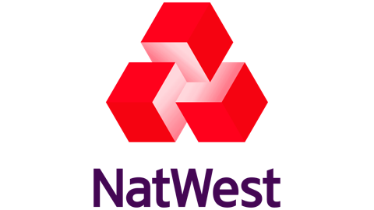 |  |  |  |  |  | 

Use Cases Across Industries
NeuralSeek + IBM Fusion is already in production across the most regulated and complex sectors of the global economy. The use cases below reflect both proven NeuralSeek deployments at named enterprise customers — including new engagements with Children’s Health (pediatric healthcare), Great Day Improvements (home services), and ITOCHU International (global trading) — and the broader set of workflows that the joint stack is uniquely positioned to deliver behind the firewall.
Healthcare and Life Sciences

Children’s Health — five enterprise AI use cases inside a top‑ranked pediatric system. Children’s Health, the leading pediatric health system in North Texas (~$3B revenue, 8,000+ clinicians and staff), is deploying NeuralSeek as a unified AI platform inside its own controlled environment — with role‑based access, full audit logging, PHI‑aware content filtering, and integration to existing IAM. CTO David Seo: “Most AI platforms promise HIPAA compliance, but NeuralSeek actually delivers with granular role‑based access, full audit logging, and content filtering built specifically for pediatric care. The fact that everything stays within our own infrastructure while still being accessible to our clinical teams is exactly what we needed.”
- Clinician‑ and staff‑facing HIPAA‑aware chatbot — a ChatGPT‑style assistant running inside Children’s tenant with SSO, RBAC scoped to each user’s role and unit, content filtering tuned for pediatric care, and a full audit trail on every prompt and response.
- Clinical policy and pathway chat with cited answers — pre‑loaded with Children’s clinical pathways, pediatric medication protocols (including weight‑based dosing), infection‑prevention standards, and regulatory guidance; clinicians get direct citations to the source policy and paragraph, auto‑refreshed when policy is republished, with PHI guardrails blocking restricted disclosures.
- OCR for referral packets and scanned charts — outside records, faxed referrals, handwritten intake forms, imaging reports and legacy scanned charts are OCR’d in place and brought directly into the chat for inline summarization and Q&amp;A.
- Self‑service pediatric cohort analytics — quality, operations and research teams ask plain‑English questions of governed datasets (readmission, length of stay, NICU throughput, ED wait times, outcomes by age band) with the underlying query and source data surfaced for audit.
- Family and caregiver call analytics — AI‑driven insight on every inbound call from families, referring providers, scheduling and nurse lines — surfacing caregiver distress signals, booking friction and coaching moments across the full volume, not just a QA sample.
Beyond Children’s Health, NeuralSeek is also deployed across other healthcare and life‑sciences workloads:
- Medical education and clinical content production — AdMed uses NeuralSeek’s no‑code AI orchestration to accelerate creation of pharmaceutical and biotech training content while preserving clinical accuracy and compliance.
- Pharmaceutical R&amp;D and regulatory drafting — grounded summarization of trial protocols, IND/NDA submissions and medical literature with verifiable citations — critical for FDA and EMA submissions.
- PHI‑safe back‑office assistants — with NeuralSeek’s real‑time PHI detection and redaction running on Fusion HCI inside the hospital firewall, providers can deploy HIPAA‑compliant assistants for coders, schedulers and patient services without sending PHI to external models.
Banking, Financial Services and Investment Research
- Public‑facing AI banking assistants under GDPR — NatWest’s Cora+ pilot uses NeuralSeek’s RAG, AI Guardrails, replay and granular governance to deliver conversational banking answers across web, mobile and online channels with full GDPR‑grade traceability.
- Investor relations and earnings‑call preparation — Verizon uses NeuralSeek AI agents to anticipate analyst questions, cross‑reference transcripts and disclosures, and generate context‑rich draft responses for executive review ahead of earnings calls.
- On‑prem AI for tier‑1 banks — BROU, the largest bank in Uruguay, runs NeuralSeek on‑premises to power internal knowledge search across over one million clients’ worth of processes and policies, with governance and audit logging suitable for central‑bank scrutiny.
- Multi‑channel customer service for pensions and payments — AFP Capital (Chile) and Clip (Mexico) use NeuralSeek to deliver consistent, policy‑compliant answers across IVR, WhatsApp, web and internal support, handling thousands of concurrent interactions while keeping regulators satisfied.
- AML, fraud and KYC support agents — dedicated, policy‑aligned agents route sensitive inquiries through OCC/FINRA/FDIC/FFIEC‑aware guardrails with full decision auditability.
Industrial, Trading and Diversified Enterprises

ITOCHU International — 107‑agent hybrid RAG financial intelligence for a Fortune Global 500 trading house. ITOCHU International, one of Japan’s "big‑5" sogo shosha (~$90B annual revenue, 120,000+ employees, operations across 60+ countries), partnered with NeuralSeek to build Itochu Insight — a hybrid RAG financial intelligence platform combining SEC EDGAR filings, live web research and private documents, orchestrated through a graph of 107 specialized agents, and deployed inside ITOCHU’s existing Azure tenant with Microsoft Entra SSO, JWT‑validated sessions and per‑tenant document isolation. Director, IT Strategy Tony Chang: “The speed and flexibility of their low‑code, no‑code development platform stand out. We were able to leverage our Azure cloud infrastructure effectively, and the deep research in full mode is quite fast. The ability to make quick fine‑tuning changes has been especially helpful for the project.”
- Hybrid RAG financial intelligence — a unified retrieval layer blending SEC EDGAR filings, live web research and ITOCHU’s private documents, using BM25 plus dense vectors to keep answers precise whether the source is a 10‑K footnote or an uploaded PDF.
- 107‑agent LangGraph orchestration — a Main Orchestrator that resolves a company and fans out to ingestion, search and analysis sub‑agents, plus a Reports Orchestrator that drives the Summary, Longitudinal, Risk and Peer Comparison decks through parallel section agents with a shared variable store.
- 5‑year XBRL financial dashboard — revenue, margins, EBITDA and ROE pulled directly from SEC EDGAR XBRL with YoY deltas and per‑metric trend charts, each metric documenting its source filing (10‑K / 20‑F / 40‑F / 10‑Q / 6‑K) and whether it was reported or derived.
- Cited, multi‑source analyst chat — Quick Scan and Deep Research modes blend SEC filings, web research and uploaded documents, with inline source attribution so reasoning is auditable back to the original artifact.
- Deterministic PDF and editable PPTX report generation — the Reports Orchestrator assembles four deck types and deterministically stitches them into polished PDFs and editable PowerPoint files, drop‑in‑ready for an analyst workflow.
Insurance
- Underwriting and claims acceleration — LLM‑enhanced OCR ingests scanned policies, claims forms and medical records, extracts entities with contextual meaning, and routes them through governed downstream workflows.
- Agent‑and‑broker enablement — grounded answers to product, eligibility and regulatory questions, sourced from approved internal knowledge with full audit trail.
Government and Public Sector
- Air‑gapped, sovereign AI for federal, state and local agencies — NeuralSeek runs fully on‑premises on Fusion HCI to satisfy FedRAMP, GovCloud, CJIS and ITAR controls, with no external dependency on public LLM providers.
- Citizen services and benefits navigation — grounded, policy‑compliant assistants help residents find programs, complete forms and understand eligibility, with PII redaction enforced inline.
- Defense and intelligence knowledge augmentation — multi‑model agents reason over classified knowledge bases inside isolated enclaves, with full prompt/response replay for oversight.
Higher Education
- University‑scale digital concierges — Penn State’s MyResource, built on NeuralSeek, serves nearly 90,000 students with personalized access to academic, health, wellness and financial aid resources — grounded in university data and protected by harmful‑language and sensitive‑data filtering.
- Research administration and grants — grounded assistants for research compliance, IRB workflows and grant documentation — with citations to institutional policy.
Home Services, Retail and Consumer Brands
Great Day Improvements — multi‑LLM, multi‑line‑of‑business AI assistant for HR and the Call Center. Great Day Improvements, a top‑5 U.S. direct‑to‑homeowner home‑improvement platform (~$1B+ combined revenue, 3,000+ employees, multi‑brand family including Patio Enclosures, Champion and Stanek), is deploying yETI on NeuralSeek — a ChatGPT‑style chat experience covering HR and the Call Center, with multi‑LLM selection, authenticated SSO‑scoped sessions, document upload and analysis, chat history and context, Great Day’s internal PDFs and Word documents pre‑indexed for RAG, and end‑to‑end deployment inside Great Day’s existing Azure tenant — with no data leaving the customer’s environment. A Phase II roadmap extends yETI into Great Day’s Databricks datalake with OAuth/SAML SSO and richer CSV/Excel/PDF/Word ingestion so analysts can reason over structured datasets alongside the existing corpus. CTO Soo‑Jin Behrstock: “It feels like a working session, not a vendor relationship. When we bring up a use case, they work through it with us and quickly turn it into something real we can see and react to. That ability to move from idea to proof of concept fast has made a big difference for us internally.”
Enterprise HR, IT and Internal Operations
- AI‑powered HR assistants — Snap’s "Chilla" Slack bot, powered by NeuralSeek, is a centralized HR assistant with strict guardrails, contextual awareness by country/city, and workflow integration (Workday, Zendesk, onboarding nudges) for a globally distributed workforce.
- Automated HR inbox triage and Center‑of‑Excellence for Agentic AI — Adobe uses NeuralSeek to triage HR inbox traffic, unify knowledge across emails/messages/documents, and run a hub‑and‑spoke CoE where business users build agents in no‑code while IT governs centrally.
- Multi‑LLM employee chat with call‑center grounding — as demonstrated at Great Day Improvements (above), NeuralSeek delivers a secure, authenticated, multi‑LLM chat experience that spans HR policy Q&amp;A and call‑center workflows in a single governed platform inside the customer’s own cloud tenant.
- IT helpdesk, ITSM and developer enablement — grounded answers over Confluence, SharePoint, ServiceNow and code repositories with real‑time, per‑document permissions enforcement.
Cross‑Industry Production Patterns
- AI‑powered PDF research and reports — parallel retrieval from internal knowledge and approved external sources synthesized into citation‑rich PDFs, as productionized in the ITOCHU Reports Orchestrator.
- SQL‑to‑PowerPoint and analyst‑deck automation — NeuralSeek queries the warehouse, drafts charts and slides, and assembles a complete deck — with governance applied to every metric cited and inline source attribution on every claim.
- Client‑ready email and Slack automation — Slack‑triggered drafting with confidence checks and human‑in‑the‑loop escalation for low‑confidence responses.
- Daily meeting and account briefings — generated from calendar events, CRM data and approved internal sources, tailored per executive and replayable on audit.
- Air‑tight virtual assistants behind the firewall — downloadable, self‑hosted AI‑agent factories built on NeuralSeek + open‑source LLMs running on Fusion HCI — the answer to "ChatGPT‑like UX without the data‑leakage risk."
Architectual Overview & Diagram (Marc to provide)
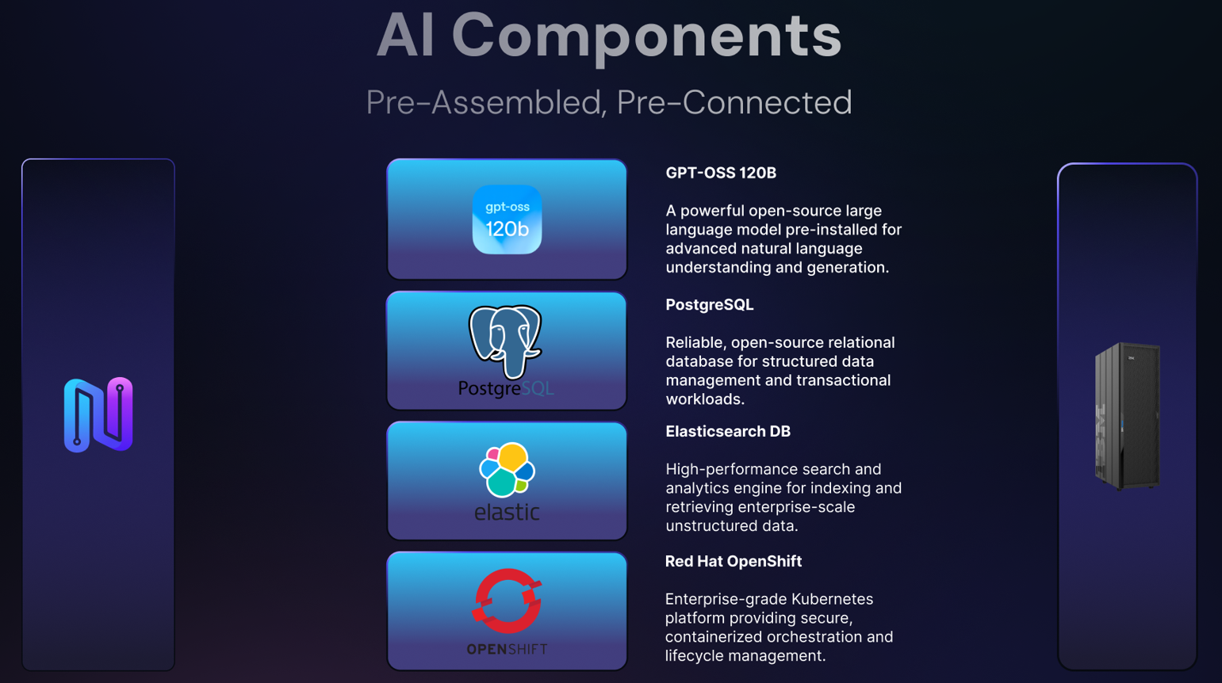
Guidelines & Sizing Recommendations (Marc/Lawrence to provide)
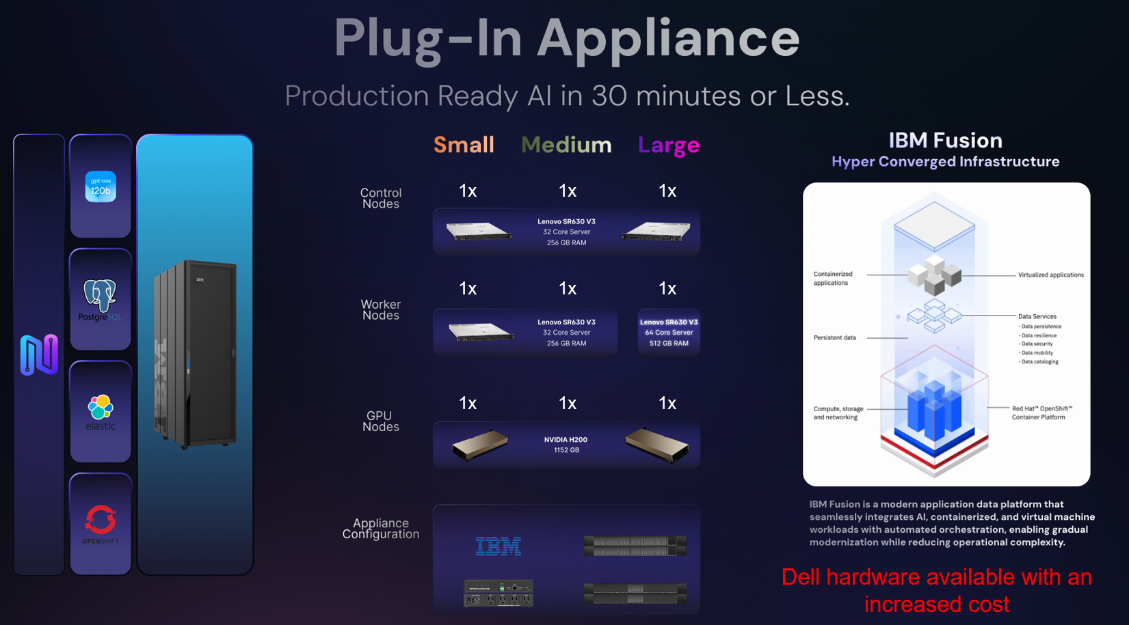
NeuralSeek + IBM Fusion HCI is offered in three pre‑configured tiers — SMALL (E01), MEDIUM (E03) and LARGE (E05) — sized to match the customer’s expected agent concurrency, model footprint, retrieval volume and storage requirements. All three tiers ship as a single, factory‑integrated rack running Red Hat OpenShift on bare metal, with NeuralSeek installed as containers on top.
Hardware Configuration by Tier
Fusion HCI Component | SMALL (E01) | MEDIUM (E03) | LARGE (E05)
Control Nodes (C10) | 3 | 3 | 3
Worker Nodes (C10) | 3 | 3 | 0
Worker Nodes (C14) | 0 | 1 | 4
GPU Nodes (G03) | 1 | 1 | 2
GPUs per G03 (NVIDIA H100 NVL) | 2 | 4 | 4
Total Worker vCPUs | 288 | 416 | 704
Total Worker Memory (GB) | 1,536 | 2,560 | 5,632
NVMe Drives (2 per node, 3.84 TB) | 12 | 14 | 14
Total Raw Storage (TB) | 46 | 54 | 54
Available Usable Storage (TB) | 14 | 16 | 16
All tiers include a Lenovo service node, dual high‑speed and dual management switches, dual PDUs and dual 24 A power cords as part of the rack base configuration. GPU selection above reflects the standard sizing assumption (NVIDIA H100 NVL); NVIDIA L40S and AMD Instinct MI210 are also supported per IBM Fusion HCI specifications.
Indicative Pricing by Tier (USD, Net of Discount)
Component | SMALL (E01) | MEDIUM (E03) | LARGE (E05)
Fusion HCI compute/storage/GPU nodes (Net + per‑node shipping) | $389,497 | $552,773 | $884,794
Fusion HCI base rack: rack, service node, switches, PDUs, freight (Net) | $115,047 | $115,630 | $125,763
Fusion HCI Software (Net) | $93,836 | $135,542 | $229,378
Premium Support — Net (Year 1 TAM) | $48,333 | $68,831 | $111,417
Total Fusion HCI Configuration — Net | $646,714 | $872,776 | $1,351,353
NeuralSeek License — Option 1 (Perpetual) | $300,000 | $600,000 | $900,000
Combined — Fusion HCI + NeuralSeek Perpetual | $946,714 | $1,472,776 | $2,251,353
NeuralSeek License — Option 2 (Annual Subscription) | $150,000 | $300,000 | $450,000
Combined Year 1 — Fusion HCI + NeuralSeek Subscription | $796,714 | $1,172,776 | $1,801,353
Pricing reflects net figures after applicable IBM and NeuralSeek discounts as modeled in the current joint sizing workbook (May 2026), inclusive of freight. Final customer quotes will reflect negotiated terms, tax, multi‑year support elections, currency, and any optional add‑ons (additional memory, 7.68 TB drives, NVIDIA NVLink, L40S GPUs, LVM drives). The combined total under the subscription option is for Year 1; subsequent years carry only the NeuralSeek subscription plus Fusion HCI premium‑support renewals.
How to Choose a Tier
- SMALL (E01) — single department, focused pilot or production rollout of one or two agentic workflows; up to a few hundred concurrent users; one GPU node (2× H100 NVL) for inference; ~14 TB usable storage. Good fit for a first on‑prem NeuralSeek + Fusion deployment or a regulated business unit standing up its own AI environment.
- MEDIUM (E03) — enterprise‑wide deployment for a mid‑sized regulated organization, multiple agent families across HR/IT/operations/compliance; thousands of concurrent users; one GPU node with 4× H100 NVL for higher inference throughput; ~16 TB usable storage.
- LARGE (E05) — multi‑LOB, multi‑tenant deployment for tier‑1 banks, health systems, federal/state agencies and global enterprises; two GPU nodes (8× H100 NVL combined); 5.6 TB of worker memory for large‑model inference and fine‑tuning; the configuration assumed for production air‑gapped workloads.
All three tiers can scale horizontally by adding GPU and worker nodes to the rack, and additional Fusion HCI racks may be federated for multi‑region or DR architectures. Contact the joint NeuralSeek + IBM team for custom sizing against specific concurrency, model and storage targets.

Conclusion
NeuralSeek + IBM Fusion is one of the few architectures capable of meeting the full stack of requirements demanded by regulated industries: security, governance, accuracy, auditability, and operational control. NeuralSeek solves the correctness and explainability problem; Fusion solves the data-sovereignty and governance problem. Together, they enable enterprises to move from prototypes to production-grade AI systems that regulators, auditors, and risk committees can trust.

